NATIONAL RESTAURANTEXCHANGE
(617) 721-9655 Fax: (781) 246-5000
DSerpone@comcast.net

Rare Opportunity Priced to Sell

Highly Successful Restaurant-in spite of Covid 19
North Shore Coastal Multi-Zoned 2 1/2 acres Real Estate
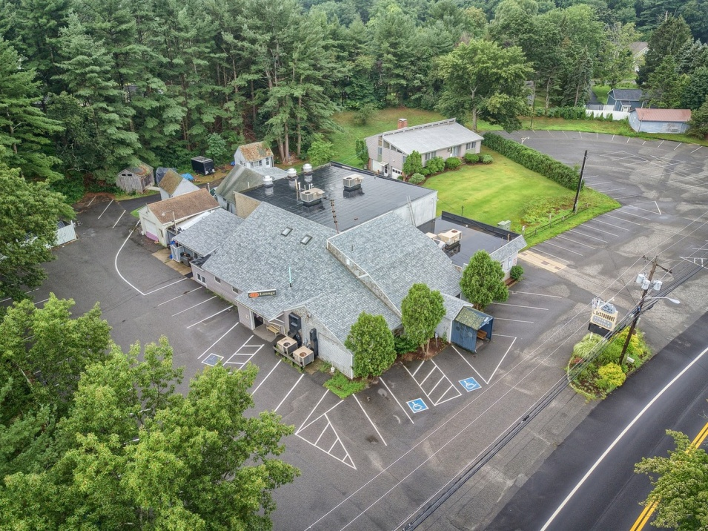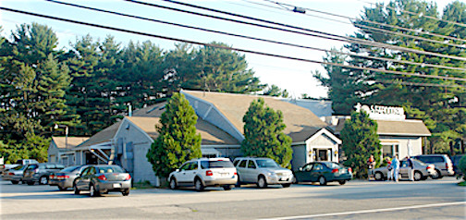

FOR EXPERIENCED RESTAURANT OWNERS
OFFERING PRICE: $400k $200 down w/1 year option on Real Estate
CURRENT BUSINESS: LANDMARK RESTAURANT
Full service, established Seafood/American Restaurant, POPULAR& HOLDING THEIR OWN DURING COVID19 CRISIS.
LOCATION: Salisbury, Ma. only seconds from the Beach, Very active, numbered route guarantees high traffic daily! Area growing by leaps and bounds.
SALES VOLUME:Pre-covid ave. $50K/wk, PostCovid:1st Week Open OUTSIDE ONLY made $30k. Hungry Traveler can’t miss!
LEASE: Reasonable …TBD
SQUARE FEET: approx.10.000 sq. ft. restaurant & functions with 2 floors.Restaurant is fully sprinkled and has town sewerage.
HOURS: Currently 11:30-8 pm Subject to change. 1:00 a.m. Liquor License
SEATING: Dining-150 seats & bar, 2nd floor functions 80 seats &23-seat bar
COMMENTS:LOYAL CUSTOMER BASE SAYS IT ALL! Established, down to earth eatery offering a mix of seafood and meat entrees, close to a pristine seacoast. Great town officials make this an easy spot to take over this very successful location. Salisbury is a wonderful coastal town with all the small town features that vacationers love with an over active ocean front boulevard made up of novelty shops, pizzerias, and food outlets. Restaurant could easily be repositioned foran 'all functions' or bldg. or expanded to accommodate 'entertainment' (lacking in area). Looking for a seasoned operator, with solid financial footing as this could be yourbest buy of the decade. Owners are retiring allowing you to take over this landmark.
FOR DEVELOPERS
North Shore Coastal Multi-Zoned 2 1/2 acres Real Estate
OFFERING PRICE: $2,500,000 for EVERYTHING
PROPERTY TYPE: Mixed Commercial/Residential Landmark
Including: 2 single family homes, 5 cabins, 2 garages & approx.10.000 sq. ft. restaurant & functions with 2 floors
LOT SIZE: 2 ½ acres YEAR BUILT: 1970 TAX RATE: $11.86/thousand
REAL ESTATE APPRAISAL:$2,050,000

For a professional showing of this lovely spot pleasecall, text or email
Marie 978-902-0350 ellesell3@gmail.comor Dennis 617-721-9655 dserpone@comcast.net or Ed 978-715-5405 edwardfwilliams@gmail.com

ALL INFORMATION IS FURNISHED BY SELLER: BROKERDOESN’T CERTIFY, WARRANT THIS INFO.

