NATIONAL RESTAURANT EXCHANGE
(617) 721-9655 Fax: (781) 246-5000
DSerpone@comcast.net

LISTING INFORMATION for: North Shore Pizzeria
GREAT OPPORTUNITY TO OWN THIS LANDMARK PIZZERIA MAKING 13K WEEKLY
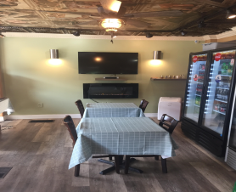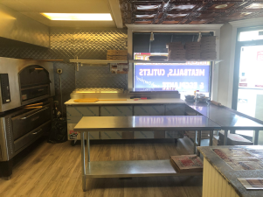
BUSINESS: Saugus - Italian Pizzeria, Subs, Salads

SELLING PRICE: $225K DOWN PAYMENT 50%

SALES VOLUME: $13,000 per wk. 40% DELIVERY

LEASE: $2,500/mo

SQUARE FOOTAGE: 1500 sq. ft.

HOURS OF OPERATION: Monday-Saturday 11:00 a.m. -8 p.m. Sunday 12:00p.m.-8:00p.m.
SEATING: 23

COMMENTS: OPPORTUNITY KNOCKS! Excellent opportunity to own long established Italian Pizzeria. Current owner has added new equipment and has grown this business to making 13K per week. This business is well known in the town and has a very loyal following. Known for fresh, homemade food!

Call Chuck at 978-317-2943 or email cwrollins01@gmail.com

ALL INFORMATION IS FURNISHED BY SELLER; BROKER DOESN’T CERTIFY, WARRANT THIS INFO.

